FROM FIELD TO FABRIC:

THE TEXTILE TOPOLOGY OF THE TAR HEEL STATE

A Geospatial Case Study in North Carolina Cotton Production, Manufacture, and Marketing at the Turn of the Twentieth Century

Lawrence Waller

Vanderbilt University

12 May 2016

Produced with the advice and research guidance of

David Carlton, Ph.D., Department of History, Vanderbilt University

*“The outstanding transformation of the South since the Civil War is the industrial evolution; crystallized in the manufacture of textiles, and creating an industrial people in the midst of an agriculturally organized society. The cotton-mill village is the ‘outward and physical sign’ of all that is taking place in this phenomenal manufacturing development.”*

—Marjorie Potwin, Cotton Mill People of the Piedmont[1]

*“The proportions for the mills producing cotton goods are of special significance, because of the magnitude of the industry in the state.”*

—The Thirteenth Census of the United States, in reference to North Carolina’s Textile Industry[2]

**ABSTRACT:** After 1880, the significance of the rapidly developing Southern Textile Industry became clear to historians, social scientists, boosters, and philanthropists. Even before 1936, when Professor Howard W. Odum of the Southern Research Council published his seminal map and table collection *Southern Regions of the United States*, attempts were made to collect, graphically present, and draw conclusions from data on Southern manufactures. Up until even the present time, however, working with and gestalting data from different historical sources was a difficult and unwieldy task, equaled in difficulty only by the challenge of presenting that data effectively to wider audiences.New developments in Geographic Information Technology and Geospatial Analysis offer a solution to researchers interested in linking such disparate places as the cotton fields of Johnston County, the mill-villages of greater Gastonia, and the fabric trading houses of Greensboro. This study, as an experiment in Digital Humanities, aims to demonstrate that the compilation of historical manufacturing data into a geospatial database makes it easier to draw conclusions about the nature of the Southern Textile Revolution as it manifested in turn-of-the-century North Carolina.

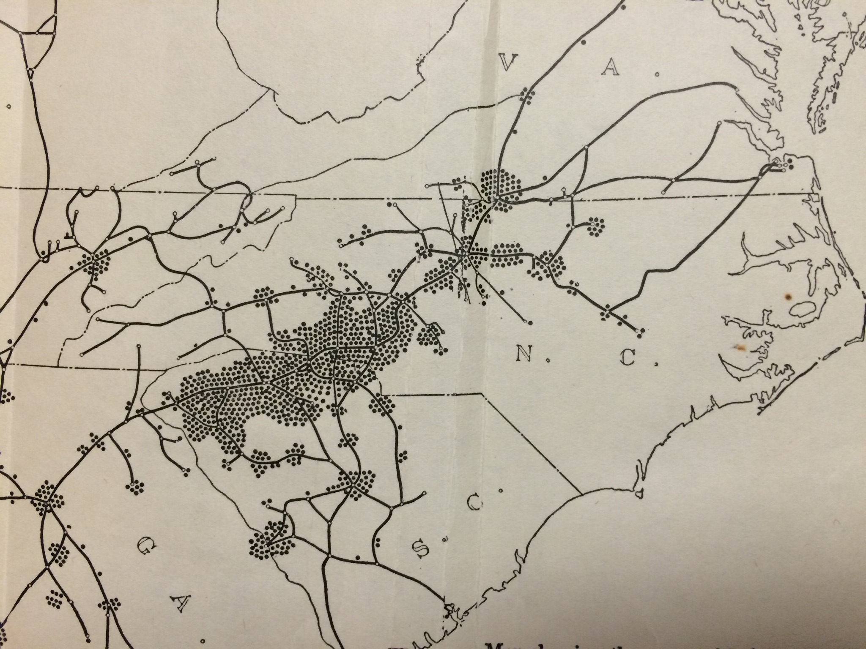

**Figure 1**: *A Textile Railway Map of North Carolina, 1925*. Each dot represents 10,000 spindles.[3]

**INTRODUCTION**

Rural, agrarian life dominated the majority of Southern states for three decades after the Civil War. Poor white farmers in Piedmont regions suffered through the transition out of landholding self-sufficiency and into staple crop tenancy, but on a daily basis they continued to live much as they had in antebellum times: planting, tending, and harvesting crops, with little exposure to the industrial forces that had long-ago swept through and modernized the Northeastern and Mid-Atlantic labor markets. The Textile Industry of the early Twentieth Century, however, introduced rapid change into the Piedmont and Mountain regions of the South. The Mill Village System—an institution that would in time prove nearly as impactful on Southern history as plantation slavery itself—served to concentrate the populations of Southern Piedmont regions in a cradle-to-grave socioeconomic framework based on textile work. Unfortunately, the industrial history of the New South remains somewhat opaque to the educated public in comparison to the well-extolled racial legacy of the antebellum plantation.

Though the primacy of the study of slavery in Southern history is easily explained, given the continuing importance of race relations in modern Southern society, the byzantine nature of the Southern Textile Industry may have also contributed to its lack of historical notoriety. It is a complicated task to dig into the textile production chain and study the integrated history of how fluffy white cotton fibers came to flow from the field to the fabric shop. Many layers of intricacy must be broached, many shibboleths recited,[4] and many modern preconceptions of labor and manufacturing discarded, to inculcate oneself into the historical framework of the Southern Textile Revolution.[5] This article aims to peel back those layers, and to visit each step of the

textile manufacturing process in detail as they manifested themselves in the mill-rich state of

North Carolina, circa 1910. Like the state of North Carolina itself, coincidentally, the textile production chain can be divided into three parts: the field, where cotton was grown; the factory, where it was processed; and the fabric agency, where it was sold. This author will propose and attempt to answer key questions related to each of these processes. How? As an experiment in Digital Humanities, this case study will demonstrate that the compilation of historical cotton production, textile manufacturing, and fabric sale data into an integrated, tripartite, geospatial database makes it easier to make readable maps, parse datasets, and ultimately come to meaningful conclusions about the nature of the Southern Textile Revolution.

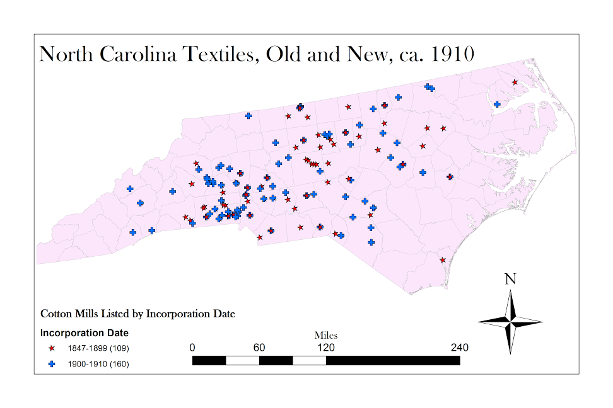

**Figure 2**: *Rapid Expansion of the Textile Industry in North Carolina, 1910*.[6]

**METHODOLOGY AND SOURCE MATERIAL**

Not all readers of this article may be familiar with the practices of Digital Humanities, specifically geospatial analysis, so before continuing I[7] will offer a brief non-technical explanation. How is history created, in general? Well, the thorough analysis of primary sources by expert historians yields data, and that data leads to a thesis—to a theory. Without a firm reliance on data, historical writing descends into the realm of popular fiction, to be consumed at Barnes and Noble and on the History Channel rather than in the classrooms of this nation’s highest institutions of learning. To twist an old aphorism, data is the ‘stuff of legend.’ The Digital Humanities, and specifically the subfield of Geographic Information Science, aim to return data to its place of primacy at the peak of historical interpretation. A Geographic Information System, or GIS, allows the correlation of locational data—say, the former location of a 2000-spindle textile mill—with a database of associated information. Rather than making maps after analyzing datasets, GIS forces scholars to view and analyze maps at each stage of the historical meaning-making process. By linking multiple historical data points to their physical locations, GIS thus makes it easy to quickly ask, obtain, and graphically present verifiable answers to historical questions. Dr. Howard W. Odum of the University of North Carolina, author of that seminal text of Southern socioeconomic analysis *Southern Regions of the United States*, certainly recognized the value of mapmaking as “a device for presenting a cumulative picture of many elemental factors […] with a view to giving graphic expression to specific combinations.”[8]The Digital Humanities simply make possible the analyses that scholars like Odum—and for that matter, cotton boosters like Daniel Augustus Tompkins—could not attempt in their own time. For example, was there a correlation between textile mill location and decreased adolescent education in North Carolina in 1910? Scholars can employ Digital Humanities methodology to quickly and definitively answer such questions, given the right datasets.[9]

What tools and datasets will be used to investigate the North Carolina textile industry? This article draws much of its source data from *Davison’s Blue Book*, *1910-1911 Edition*, an 861-page directory of nationwide textile mills, firms, corporations, and associated relevant operations. The Davison Publishing Company catered to makers and sellers of fiber processing machinery in Lowell, Massachusetts and Philadelphia, the historic capitals of American fabric enterprise. Because Northern salesmen were unfamiliar with Southern markets, they needed the *Blue Book* to tell them how many spindles and looms Southern operators were running in order to calculate how many replacements Southerners might be interested in buying—and just where in the Piedmont those buyers would be located. As a result, the *Blue Book* publishers acquired detailed locational, financial, and industrial data on every cotton mill operating in or under construction in 1910 North Carolina. This author digitized the *Blue Book* and transferred its North Carolina dataset into an ESRITM Geographic Information System, ArcGIS 10.3 proprietary database. Additional relevant data with respect to historical cotton and fabric prices, worker wages, and industry spending were then branched in and spatially joined to the *Blue Book* dataset; this data was acquired from the Agricultural, Population, Manufacturing, and Statistical Abstract volumes of the Thirteenth Census of the United States. Technical specification data on cotton mill engineering comes from the aforementioned D. A. Tompkins’ manufacturing guide *Cotton Mill Commercial Features.* Lastly, basic information regarding firms engaged in the terminal stage of textile production—marketing the finished materiel—was obtained from the encyclopedic final chapters of Frank Walton’s text *Tomahawks to Textiles: The Fabulous Story of Worth Street.*

**EXAMPLE 1: HOW IMPORTANT WAS NATIVE NORTH CAROLINA COTTON TO TEXTILE PRODUCTION?**

In comparison to its fire-eating southern neighbor, North Carolina was a reluctant subject of that dictatorial, short-lived ruler of the Confederacy, King Cotton. One can wonder whether Governor Ellis would have even led the state to secession had President Lincoln not attempted to raise troops there to put down the rebellion of its sister Carolina. Part of this aloofness with respect to the cause of plantation slavery lies in North Carolina’s low utilization of slave labor for cotton production with respect to the rest of the Deep South states. Indeed, two of the state’s three major subdivisions, the Mountains and the Coastal Pine Barrens, were and are entirely inhospitable to cotton production on the scale necessary to support industrial production of fiber. As of 1910, by which time long leaf pine deforestation and frequent application of fertilizer made possible the dissemination of cotton production along the upper Pine Barrens, eight of that region’s coastal counties still yielded less than 2000 bales apiece, with twenty-six Mountain counties growing no cotton whatsoever.[10] Furthermore, North Carolina’s comparative disadvantage in cotton production with respect to the rest of the South increases when one takes into consideration the agreeability of the state’s soil to tobacco cultivation. Although the state produced just 11 million pounds of tobacco in 1870, by 1900 it was the nation’s largest supplier of smoking supplies, cultivating 127.5 million pounds.[11] North Carolinian trademark ‘brightleaf’ or gold tobacco brought the state a great deal of notoriety, and could be raised in poor soil with little of the exhaustive fertilizer consumption that characterized Tar Heel cotton production. This, in combination with falling land ownership and rising tenancy—from just 33% in 1880 to 42.8% in 1910—made it unprofitable for cash-strapped farmers to grow cotton.[12]

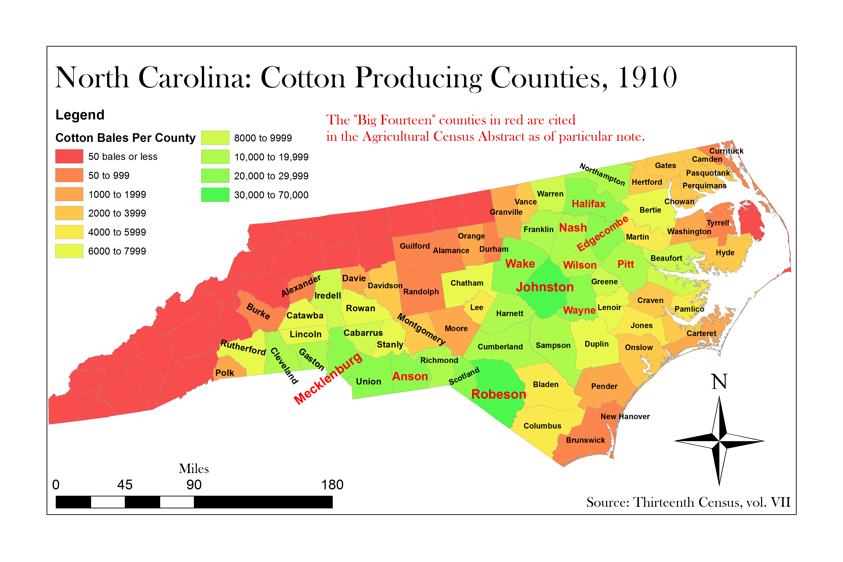

**Figure 3**: *An Overview of Cotton Production by the Bale in North Carolina, 1910*.[13]

Proceeding on to the first research question, what meaningful conclusions can be drawn from North Carolina cotton production statistics in correlation with the rest of the data described above? In his essay on the history of the Charlotte textile industry, Dr. Thomas Hanchett channels the theories of the aforementioned notorious Charlottean booster Tompkins by arguing that North Carolina was well-suited to cotton production because one could “Bring the Mills to the Cotton.” It is at least feasible to hypothesize, on a precursory examination of historical data that proximity to cotton production made it advantageous to mill fiber in North Carolina. As Lee Brooks’ *Manual to Southern Regions* points out, after all, it is unusual that the South built a “great industry in the face of what the experts said was certain defeat because the South could [presumably] not hope to compete with New England in the manufacture of cotton goods.”[14] Could localized raw cotton production be the success factor whose presence Brooks implies aided North Carolinian textile production?

In short: No. This question is easier to answer than it might be originally believed, given the integrated nature of the ArcGIS database, but the calculations involved require some background explanation. The Census data, summarized in **Fig. 2**, lists bale production by North Carolina County. While some North Carolina mills of course ran integrated spinning and weaving operations,[15] the majority operated mainly spindles and produced thread. Regardless, since the process of fabric-weaving consumes not raw cotton but rather spun thread, only the input requirements of mills engaged in spinning need be accounted for to determine statewide raw cotton consumption statistics. Now, mill owners measured the thickness of the thread that they marketed in hank count—that is, how many hanks[16] it took to accumulate a pound of yarn. At first glance, it seems impossible to generate reliable input and output statistics. The cotton spinning process was by no means 100% efficient; carding and combing alone generated a great deal of short-fiber waste. So how can the raw consumption figures for mills be reliable calculated? Fortuitously, manufacturing expert Tompkins spent over 20 years studying the process. In his book for perspective mill operators, he provides a chart indicating how much cotton a spindle producing given hank count required per year, presumably to help his clients estimate how much cotton they needed to procure and how many spindles they could feasibly buy and operate. Completing this ‘golden data braid,’ as cross-disciplinarian Douglas Hofstadler might call it, *Davison’s Blue Book* lists exactly how many spindles North Carolina mills operated, and what hank counts those mills produced.

|  |  |  |  |  |  |  |  |  |
| --- | --- | --- | --- | --- | --- | --- | --- | --- |
| Hank Ct. | 4 | 6 | 8 | 10 | 12 | 14 | 16 | 18 |
| Bales Reqd. per Annum | 1650 | 1100 | 900 | 600 | 500 | 400 | 350 | 300 |
| Hank Ct. | **20** | **25** | **30** | **35** | **40** | **45** | **50** | **60** |
| Bales Reqd. per Annum. | 250 | 200 | 170 | 150 | 110 | 95 | 85 | 60 |

**Table 1**: *Number Of Bales Of Cotton Annually Consumed By 1,000 Spindles On Different Yarn Numbers.*[17]

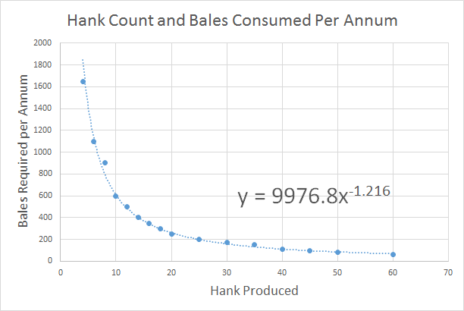 How did analysis on the data described above proceed? **Table 1** above, extracted from Tompkins’ *Cotton Mill Commercial Features*, lists the number of bales of cotton annually consumed by 1000 standard spindles to produce different yarn numbers. When analyzed in Excel, the data points in Table 1 yielded an acceptable power regression equation of y = 9976.8x-1.216, as shown below in **Fig. 4**; this equation allows those mills producing odd-numbered and unlisted numbers of hanks of yarn to be compared apples-to-apples with those mills producing even-numbered hanks. Next, it was necessary to decide how to treat those spinning mills that listed more than one hank grade in their capacity in the *Blue Book*. For purposes of simplification an ‘average hank’ rating was computed for each mill by comparing the largest and smallest hanks listed in each mill’s *Blue Book* entry. Out of 331 mills, 53.47% or 177 mills had enough data available to compute cotton consumption—that is, their spindlage and hank specializations were listed in the *Blue Book*. The result: the mills listed consumed approximately 418,929.8572 bales of cotton in the year 1910. How does this result compare to the cotton production in North Carolina? According to the Thirteenth Census’s Agriculture Volume, North Carolina produced around 666,135 bales of cotton that year. Based on this data alone, Tompkins’ theory that North Carolina could spin Tar Heel-grown cotton is theoretically feasible, although it is important to note that a large number of the mills listed as spinning mills in the *Blue Book* did not provide hank counts; the bale consumption number is probably much higher than the theoretical yield calculated. Unfortunately, no conclusive conclusion can thus be drawn from this analysis. The limitation of the dataset simply shows through.

**Figure 4**: *Power Regression on Table 1, used to calculate Mill Consumption of Cotton fiber by the bale.*

However, this simple analysis does not take into consideration the fact that cotton moved from one end of the state to the other would cost basically the same in freight rates as cotton moved across state lines, say from South Carolina. Assuming that, in order for Tompkins’ assertion to be valid, mills must be able to draw cotton from within their counties of origin, how does the theory hold up? ArcGIS sheds further light on the situation; see **Figure 5** below. The vast majority of the cotton mills in 1910 North Carolina, the database reveals, were concentrated in counties that were not self-sufficient cotton producers. Gaston County, for example, home to 13% of the state’s mills and 12% of its operating spindlage, would have imported over 35,000 bales from outside counties. Such cotton would have come from South Carolina’s Black Belt or the Lower Piedmont of North Carolina, incurring substantially higher shipping rates compared to collecting from the nearby countryside, as Tompkins implies. Leading producers in Alamance and Rockingham Counties would have also needed to import cotton from distant fields, as the rural regions of those two counties suffered from poor soil and were thus dominated almost

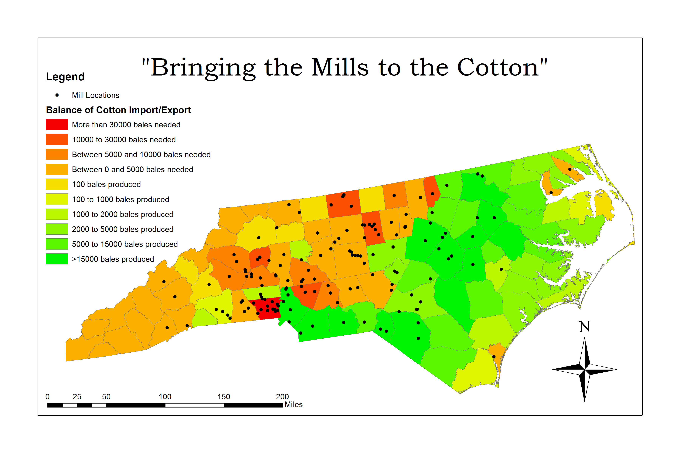

**Figure 5**: *Comparing Cotton Production and Consumption by North Carolina Counties, 1910.*[18]

exclusively by the cultivation of tobacco. To conclude: it does not matter whether the state of North Carolina itself was self-sufficiently producing enough cotton to fuel the textile industry, which the first analysis indicates may have been possible. The cotton import imbalances, which would have only grown following 1910 as tobacco cultivation increased during the lead-up to World War I, disprove the thesis. No, it appears far more likely that other factors, such as the North Carolinian labor market extolled by Professor Brooks, explain the success of its textile industry. As Brooks argues, North Carolina had “a practically unlimited resource in the abundance of a native-born, homogenous labor force from which to man its industries.”[19] This, rather than its native cotton, likely proved the state’s true comparative advantage with respect to the established New England textile order.

**EXAMPLE II: ON EDUCATION IN TEXTILE REGIONS**

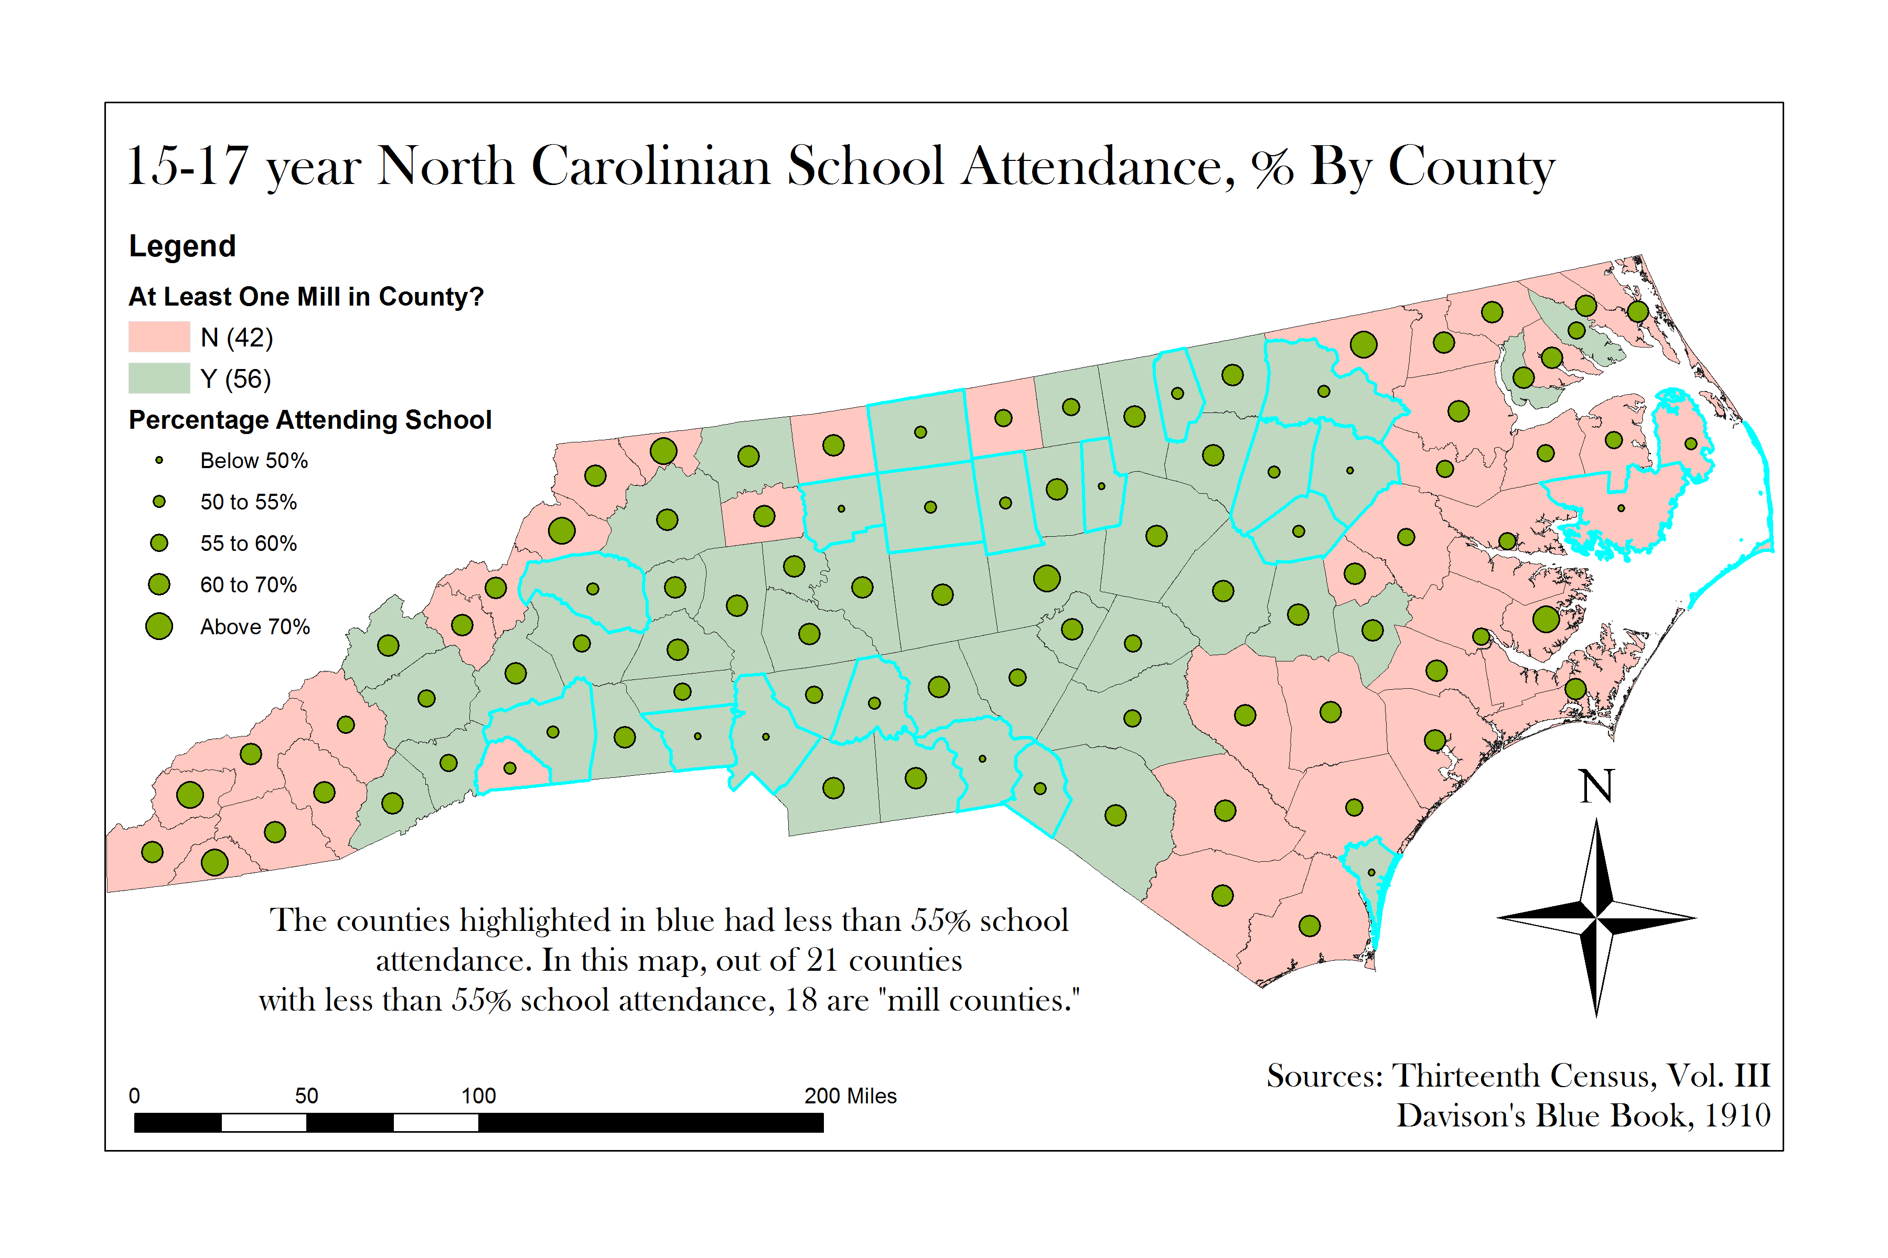

**Figure 6**: *A Cartogram of Textile Mill Distribution by North Carolina County, 1910.*[20]

1910 North Carolina had no compulsory education laws. Even in 1913, when such reforms were enacted, they only applied to children up to the age of 12. Although children of all ages could perform menial labor of one sort or another in textile mills, those children over the age of 15 proved most useful to textile companies. Was there a notable difference between 15-17 year old school enrollments in counties dominated by the textile industry? GIS technology makes it possible to graphically answer this question. As **Figure 6** clearly demonstrates, school enrollment rates for children aged 15-17 were markedly lower in textile-producing counties, and the results are statistically significant. Furthermore, as **Fig. 7** shows, there is a direct correlation between the importance of textile work to a county, measured by the number of operating spindles in that county, and diminished educational opportunities. The more spindles per county, the greater the amount of economic control exerted by textile corporations—implying fewer opportunities available for non-textile work, even in agriculture.

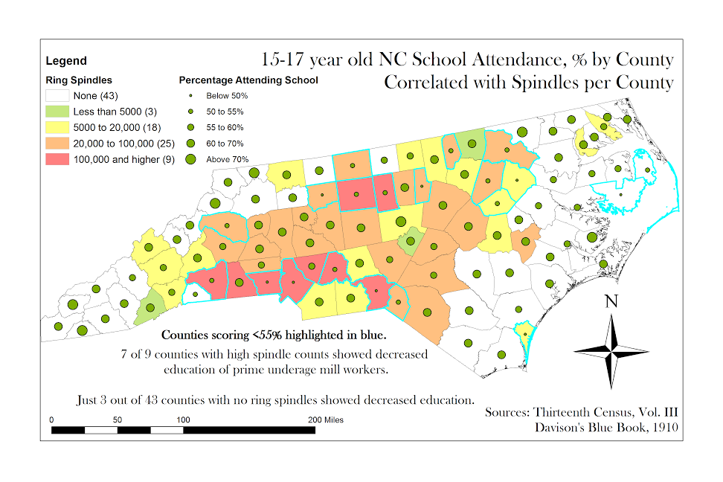

**Figure 7**: *A Cartogram of Textile Mill Distribution by North Carolina County, 1910.*[21]

Why are these results relevant? In her analysis of the Carolina Piedmont textile industry, historian Marjorie Potwin writes that to “measure the social change which [cotton mills] have wrought we must know the truth about their influence over the lives of men, women, and children.”[22] Current scholarly frameworks depict textile corporations as all-encompassing socioeconomic Leviathans; but much statistical work, such as that performed in this study, remains to be done to verify this popular thesis. As the aforementioned textile scholar Professor Jennings Rhyne proved in his 1926 statistical study *Some Southern Mill Workers and their Villages*, for example, the Mill Village system dominated every aspect of the lives of textile workers. Mill workers married mill workers. They shopped at company stores. They participated in mill baseball leagues over the summers. Lastly, and most importantly, the children of textile workers attended schools largely funded and controlled by the same business interests that hired them.[23] It is not unfeasible to postulate that textile firms may have even actively culled or recruited teenagers from the schools that they operated. This study offers conclusive evidence to support the conclusions of Professor Rhyne and other textile statisticians—that mill towns impeded the educational and socioeconomic opportunities of their employees—by showing that mill children were more likely to abandon their studies in order to help support their families.

**EXAMPLE III: SKILLED AND UNSKILLED LABOR IN THE FACTORY**

Southern history is rife with examples of ‘sick’ industries, or industrialization marked by the proliferation of unskilled labor and the creation of poor-quality materials. Despite advantageous proximity to iron ore, for example, capital limitations and market forces limited Birmingham furnaces to producing pig iron while Carnegie and U.S. Steel made high-quality architectural steel in Pittsburg. So was the textile industry in 1910 North Carolina sick, compared to textile production in New England? Absolutely. Whereas New England spinning mills operated both ring and mule spindles, North Carolina mill owners invested almost exclusively in ring spindles. Figure X below, an ArcGIS point map, makes the disparity between the proliferation of the two classes of spindles in the state immediately clear. Why is the type of spindlage significant? Unskilled, female, and underage workers typically worked ring spindles, which produced lower quality hanks of yarn but which could be operated continuously. Mule spindles, in contrast, produced higher quality material from fiber inputs. Furthermore, the weight of mule frames required skilled male operators, who received high compensation for the difficulty of the spinning task that they performed. In short, the dearth of mule spindles throughout North Carolina textile regions—especially in Gaston and Mecklenburg Counties, home to the state’s largest textile manufacturing operations, indicates the provincial nature of the North Carolina textile industry in comparison with that of New England.

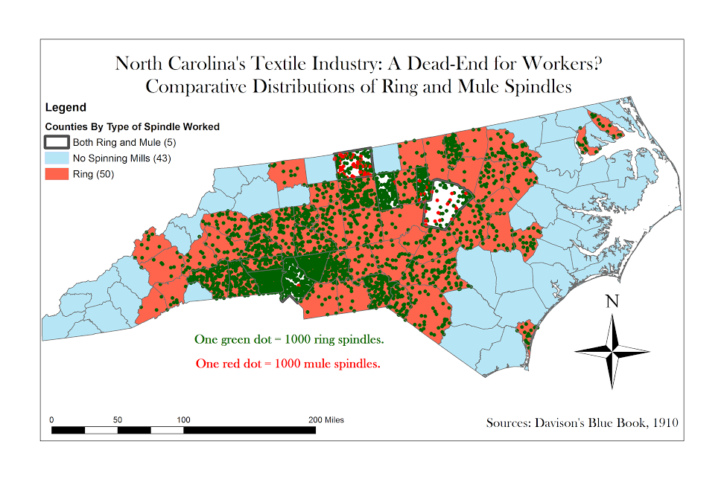

**Figure 8**: *A Cartogram of Textile Mill Distribution by North Carolina County, 1910.*[24]

**EXAMPLE IV: TRENDS IN TEXTILE SALES**

Though the first half of the 19th Century, American textile industries lagged behind their British counterparts. But starting in the year 1850, American native textile production reached parity with British imports into New York City. That same year, the Worth Street District in that city was established as a national hub for the purchase of American textiles.[25] Unfortunately, while more-established New England cotton mills quickly shifted their business from local agents to dealers on Worth Street, Southern mills were reluctant to do so. D. A. Tompkins rails against foolish mill owners trying to sell goods through agents in the rural South rather than on Worth Street: “Those who embark in this business should look entirely to a wholesale market. The idea of having an agent in every country village is ridiculous […] goods should be forwarded precisely as a planter's cotton is,” he writes in his textile primer.[26] What was the relationship between North Carolina textile firms and Worth Street? How many North Carolina mills sold direct as opposed to hiring a specific selling agent on Worth Street, or in the other textile hubs of the day, Greensboro and Philadelphia, to contract with them wholesale? Was Tompkins correct in his frustration?

|  |  |  |  |  |
| --- | --- | --- | --- | --- |
| Worth Street | Philadelphia | Greensboro | Direct Sales | Only Direct |
| 119 Mills | 72 Mills | 28 Mills | 82 Mills | 170 Mills |

**Figure 9**: *Number of North Carolina Mills Selling Fabric in Particular Locales, 1910.*[27]

The data from *Davison’s Blue Book* indicates that Tompkins did indeed have cause for concern. Out of 331 North Carolina mills, 170 or 51.36% did not operate a warehouse or deal with an agent in any of the three cities listed—New York, Philadelphia, or Greensboro. Furthermore, North Carolinian textile involvement with Worth Street was particularly low, with only 119 or 35.95% of firms choosing to work with a selling agent or open an office there. By avoiding Worth Street, Southern textile firms may have disconnected themselves from the larger textile market.

**ADDITIONAL EXAMPLES: A TEXTILE MAP APPENDIX**

The majority of the time spent on this project was invested in map-making and research. As might be expected, not all of the maps meshed well with the examples extolled above. Nevertheless, these findings certainly merit further research. An appendix of relevant maps generated from the geospatial database described in the essay above follow, along with a brief analysis of each, in order to demonstrate the usefulness of various GIS mapping techniques.

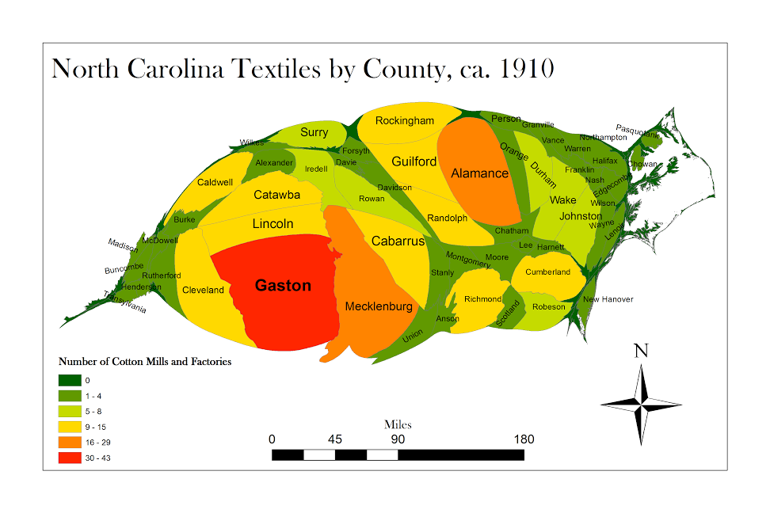

**Figure 10**: *A Cartogram of Textile Mill Distribution by North Carolina County, 1910.*[28]

The ArcGIS database provides a wide variety of available add-ons to generate various kinds of potentially useful maps. In this map, county areas have been scaled—while maintaining geographic border consistency—to indicate the number of textile facilities per North Carolina county, as listed in the *Blue Book*. This cartogram is useful because it allows the comparison of actual county areas to their mill counts, thus demonstrating ‘mill density’ as well.

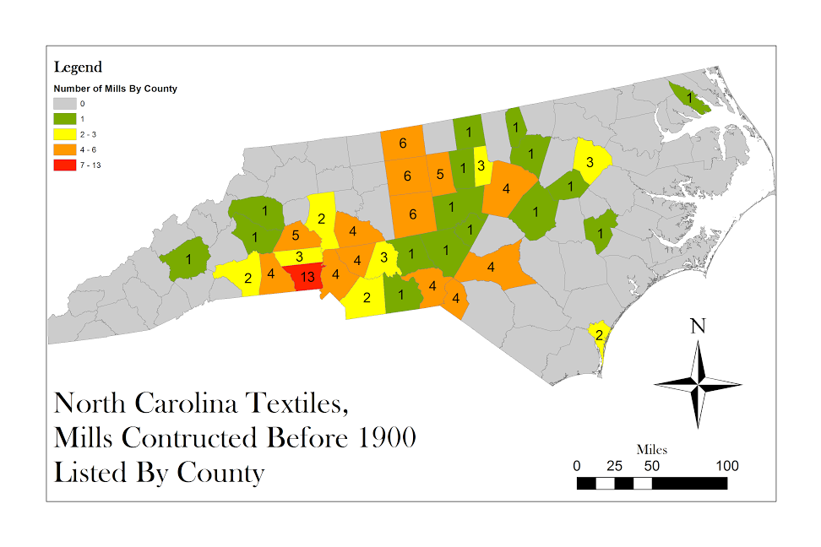

**Figure 11**: *North Carolina Mills Still Operating in 1910 with Incorporation Dates before 1900.*[29]

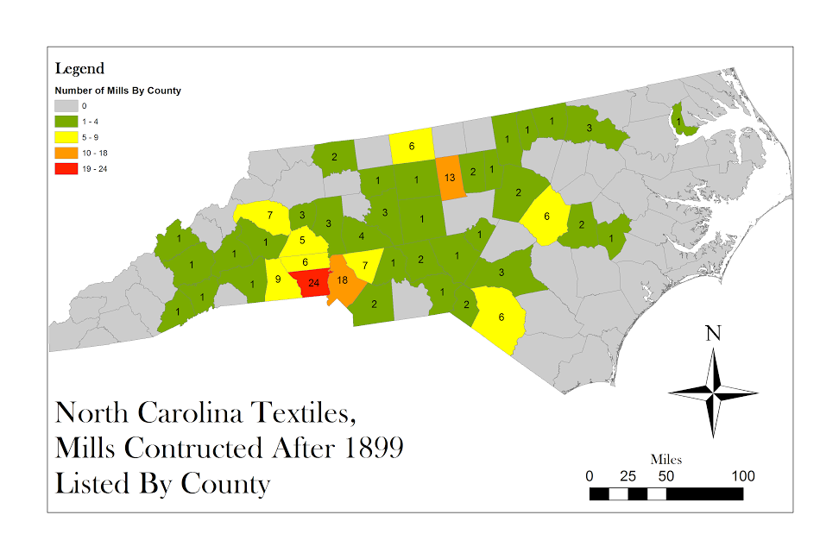

**Figure 12**: *New North Carolina Mills, with Incorporation Dates after 1900.*[30]

Which North Carolina counties were well established ‘mill counties?’ Which regions was the Textile Revolution just beginning to penetrate in the decade between 1900 and 1910? The previous two maps, when shown side-by-side, allow this question to be easily answered. As of 1910 textiles had just begun to expand into the Mountain Counties; previously high growth in mill construction in central Piedmont counties began to slow.

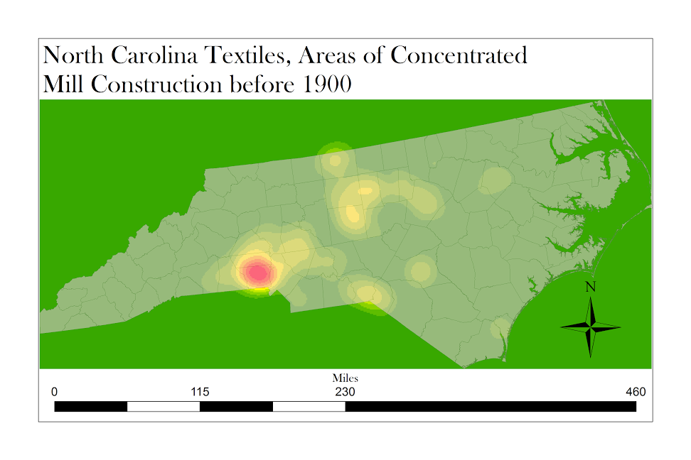

**Figure 13**: *New North Carolina Mills, with Incorporation Dates after 1900.*[31]

Kernel Density Analysis is used to smooth out point data—such as the locations of textile mills—in order to determine areas of influence and convert geospatially-tagged locations into rasters, or heat maps. This map shows established mill towns as of 1910, essentially a rehashing of the dataset shown above in **Fig. 12.** Density mapping was used to create an influence map indicating areas where textile companies would have influenced the daily lives of ordinary people. The brighter the color, the larger the number of mills within a certain distance of the land illuminated with that color. The map above provides a far more effective definition of North Carolinian regions of textile growth than the quantized map county by county. Especially in rural regions, socioeconomic phenomena rarely subscribe to arbitrary political boundaries.

Was there an influx of population into textile-producing counties between 1900 and 1910? Statistical correlations indicate so. However, the following map helps to visually demonstrate population movement within North Carolina far more effectively than mere tables of data. It integrates population change by county from the Thirteenth Census—indicating

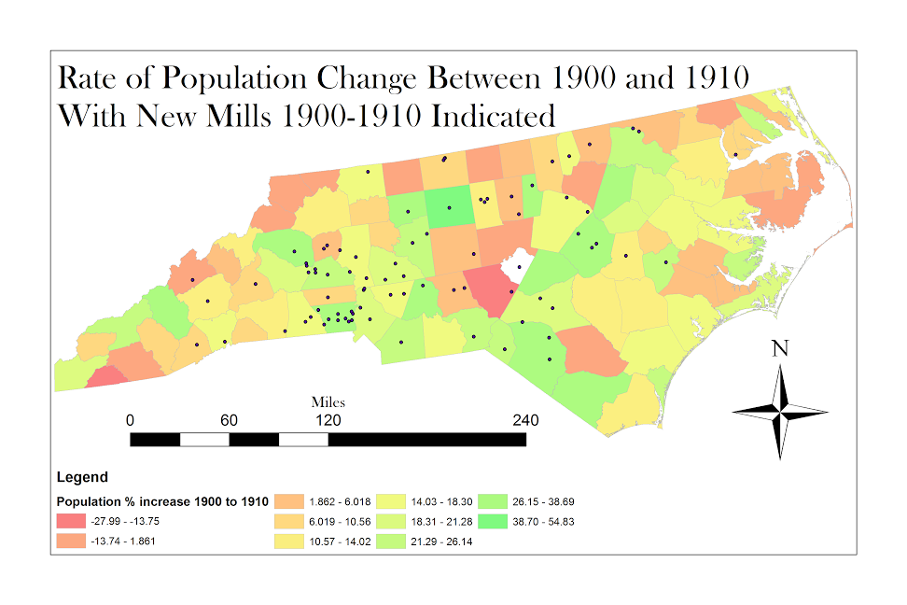

**Figure 14**: *North Carolina Population Change Correlated with New Mill Construction, 1900-1910.*[32]

the changes taking place since the Twelfth Census in 1899. The black dots indicate mills founded in the years between 1900 and 1910; it quickly becomes evident from a precursory examination of the map that those counties with more than three new mills demonstrate drastic population growth, while a statistically significant number of counties with less textile development show population decreases or static levels of growth. The seemingly arbitrary percentage categorizations on the map were in actuality computed by jenking the dataset in order to create natural divisions between the color groups.

**CONCLUSION**

North Carolina at the end of the 1900s was a state largely influenced by, if not truly

dominated by, the production, processing, and sale of cotton. The state produced a sizeable proportion of the cotton that its mills consumed, although not in the right county-by-county geospatial proportions to truly justify the theory that North Carolina firms saved money by ‘bringing the mills to the cotton.’ Its mills dominated the lives of its workers, and textile employees crafted an entire cultural experience and lexicon around the harsh jobs that they performed between 54 and 72 hours a week without much chance for educational advancement.[33]

Train or truck brought cotton to and products from the isolated mill-villages of the Piedmont;[34] this cotton traveled to local warehouses and Greensboro agents in addition to the clearinghouses of Worth Street or Philadelphia. As this brief study has demonstrated, geospatial analysis can be a useful tool for historians employing the Digital Humanities to come to conclusions about datasets. Although many historians might appreciate GIS merely for the convenient maps it can generate, its true value as a correlative database management system able to gestalt numerous disparate data sources, should not be underestimated.

Works Cited

Brooks, Lee. *Manual for Southern Regions to Accompany Southern Regions of the United States by Howard W. Odum.* Chapel Hill: University of North Carolina Press, 1937.

Davison Publishing Company. *The Blue Book: Textile Directory, United States and Canada.* 23rd

Annual Edition, 1910-1911. New York: Davison Publishing Company, 1910.

NC Business Hall of Fame. “Agribusiness.” North Carolina Business History. www.historync.org/agriculture.htm (accessed May 12, 2016).

Odum, Howard. *Southern Regions of the United States.* Chapel Hill: University of North

Carolina Press, 1936.

Potwin, Marjorie. *Cotton Mill People of the Piedmont: A Study in Social Change*. New York:

Columbia University Press, 1927.

Rhyne, Jennings. *Some Southern Cotton Mill Workers and Their Villages.* Raleigh: University of

North Carolina Press, 1930.

U.S. Bureau of Statistics. *Stastical Abstract of the United States*, 1910. Washington: Government Printing Office, 1911.

U.S. Census Bureau. *Thirteenth Census of the United States Taken in the Year 1910*. Vol. III:

Population. 1912. New York: Norman Ross Publishing, 1999.

U.S. Census Bureau. *Thirteenth Census of the United States Taken in the Year 1910*. Vol. VII:

Agriculture, 1909 and 1910, Reports by States, with Statistics for Counties: Nebraska-Wyoming, Alaska, Hawaii, and Porto Rico. 1913. New York: Norman Ross Publishing, 1999.

U.S. Census Bureau. *Thirteenth Census of the United States Taken in the Year 1910*. Vol. IX:

Manufactures, 1909, Reports by States, with Statistics for Principal Cities. 1912. New York: Norman Ross Publishing, 1999.

Walton, Frank. *Tomahawks to Textiles: The Fabulous Story of Worth Street.* New York: Appelton-Century-Crofts, 1953.

1. Marjorie Potwin, *Cotton Mill People of the Piedmont: A Study in Social Change* (New York: Columbia University Press, 1927), 13.
2. U.S. Census Bureau, *Thirteenth Census of the United States Taken in the Year 1910*, Vol. IX: Manufactures, 1909, Reports by States, with Statistics for Principal Cities, 1912 (New York: Norman Ross Publishing, 1999), 901.
3. Southern Railway Company, map showing the geographical distribution of the textile industry in territory served by the Southern Railway System, 1925 [map], Scale Unlisted, In: Potwin. *Image remains the copyrighted property of its owner. Included under fair use exemption of the U.S. Copyright Law and restricted from further use.*
4. Fin-de-siècle textile production was not even a uniform process; it differed from mill to mill and even the seemingly smallest technical elements greatly impacted the culture and circumstances of textile workers. Corporate management style, building layout, and even spindle type determined the well-being, pay, and skill level of workers. For some of the determining factors in spinning mill design and their rationales, see Daniel Tompkins, *Cotton Mill Commercial Features* (Charlotte: Self-Published, 1899), beginning on 153.
5. To give one brief example, one cannot even place ‘Mill Towns,’ villages controlled by textile corporations, into a single definitive category for analysis. Professor Jennings Rhyne identifies four vastly different subtypes of North Carolina mill town in his 1926 study *Some Southern Cotton Mill Workers and their Villages* (Raleigh: University of North Carolina Press, 1927), 37-63.
6. Scale 1 in. equals 70 miles, Data from *Davison’s Blue Book*, 128-160, map by Lawrence Waller. *Map Copyright Lawrence A. Waller, 2016. Reprinting without the express permission of the author is strictly forbidden, except for educational use or historical research.*
7. The intrusion of the author in the first person is of course typically avoided in historical research, but I felt that my personal explanation might clarify questions for those not learned in both the Computer Engineering and History fields as I am—a very unusual academic background (yet fortuitous for study of the topic at hand).
8. Howard Odum, *Southern Regions of the United States* (Chapel Hill: Univ. of North Carolina Press, 1936), 3.
9. This very question, in fact, is answered later in the article.
10. U.S. Census Bureau, *Thirteenth Census of the United States Taken in the Year 1910*, Vol. VII: Agriculture, 1909 and 1910, Reports by States, with Statistics for Counties: Nebraska-Wyoming, Alaska, Hawaii, and Porto Rico, 1913 (New York: Norman Ross Publishing, 1999).
11. NC Business Hall of Fame, “Agribusiness,” North Carolina Business History, www.historync.org/agriculture.htm (accessed May 12, 2016).
12. Thirteenth Census, Vol. VII.
13. North Carolina Cotton Producing Counties [map], Scale 1 in. equals 70 miles, Data from the Thirteenth Census of the United States, Vol. 3, p. 231, map by Lawrence Waller. *Map Copyright Lawrence A. Waller, 2016. Reprinting without the express permission of the author is strictly forbidden, except for educational use or historical research.*
14. Brooks, *Manual to Southern Regions*, 75.
15. **Integrated operations**: Cotton textile production in the mill is essentially a two-step process. After being **spun** into thread, cotton was then **woven** into fabric. Some mills conducted both operations; others participated in only one stage of the process. The *Blue Book* conveniently lists the factories that ran integrated operations.
16. A **hank**, irrespective of thread thickness or volume, measured **840 linear yards**.
17. Showing The Number Of Bales Of Cotton Annually Consumed By 1,000 Spindles On Different Yarn Numbers. [Table], Data from Tompkins, *Cotton Mill Commercial Features*, 73. *In the Public Domain.*
18. Scale 1 in equals 75 miles, Data from the Thirteenth Census of the United States, Vol. 3, 231, and *Davison’s Blue Book*, 128-160, map by Lawrence Waller. *Map Copyright Lawrence A. Waller, 2016. Reprinting without the express permission of the author is strictly forbidden, except for educational use or historical research.*
19. Lee Brooks, *Manual for Southern Regions to Accompany Southern Regions of the United States by Howard W. Odum* (Chapel Hill: University of North Carolina Press, 1937), 75.
20. Scale 1 in equals 70 miles, data from the Thirteenth Census of the United States, Vol. 3, and from *Davison’s Blue Book*, 128-160, map by Lawrence Waller. *Map Copyright Lawrence A. Waller, 2016. Reprinting without the express permission of the author is strictly forbidden, except for educational use or historical research.*
21. Scale 1 in equals 70 miles, data from the Thirteenth Census of the United States, Vol. 3, and from *Davison’s Blue Book*, 128-160, map by Lawrence Waller. *Map Copyright Lawrence A. Waller, 2016. Reprinting without the express permission of the author is strictly forbidden, except for educational use or historical research.*
22. Potwin, 20.
23. Rhyne, 18, 55, and 63.
24. Scale 1 in equals 70 miles, data from *Davison’s Blue Book*, 128-160, map by Lawrence Waller. *Map Copyright Lawrence A. Waller, 2016. Reprinting without the express permission of the author is strictly forbidden, except for educational use or historical research.*
25. Frank Walton, *Tomahawks to Textiles: The Fabulous Story of Worth Street* (New York: Appelton-Century-Crofts, 1953), 102.
26. Tompkins, 232.
27. Scale 1 in equals 70 miles, data from the Thirteenth Census of the United States, Vol. 3, and from *Davison’s Blue Book*, 128-160, map by Lawrence Waller. *Map Copyright Lawrence A. Waller, 2016. Reprinting without the express permission of the author is strictly forbidden, except for educational use or historical research.*
28. Scale 1 in equals 70 miles, Data from *Davison’s Blue Book*, 128-160, map by Lawrence Waller. *Map Copyright Lawrence A. Waller, 2016. Reprinting without the express permission of the author is strictly forbidden, except for educational use or historical research.*
29. Scale 1 in equals 175 miles, Data from *Davison’s Blue Book*, 128-160, map by Lawrence Waller. *Map Copyright Lawrence A. Waller, 2016. Reprinting without the express permission of the author is strictly forbidden, except for educational use or historical research.*
30. Scale 1 in equals 175 miles, Data from *Davison’s Blue Book*, 128-160, map by Lawrence Waller. *Map Copyright Lawrence A. Waller, 2016. Reprinting without the express permission of the author is strictly forbidden, except for educational use or historical research.*
31. Scale 1 in equals 175 miles, Data from *Davison’s Blue Book*, 128-160, map by Lawrence Waller. *Map Copyright Lawrence A. Waller, 2016. Reprinting without the express permission of the author is strictly forbidden, except for educational use or historical research.*
32. Scale 1 in equals 175 miles, Data from *Davison’s Blue Book*, 128-160, map by Lawrence Waller. *Map Copyright Lawrence A. Waller, 2016. Reprinting without the express permission of the author is strictly forbidden, except for educational use or historical research.*
33. *Thirteenth Census*, Vol. 7.
34. Rhyne, 48.